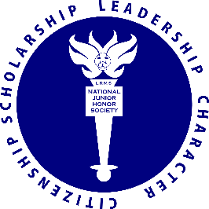
April 2019

Dear Leesville Road Middle School 7th Grade Students:

This letter is to inform you about the National Junior Honor Society selection process. We will induct our new class of members the fall of 2019. Seventh grade students who have maintained a minimum GPA of 3.5 in sixth grade and on their seventh grade first semester report cards become candidates for selection into the Leesville Road Middle School Chapter of the National Junior Honor Society. Candidacy and application do not mean automatic admittance.

Selection and membership for the National Junior Honor Society at Leesville Road Middle School is based upon five principles: character, citizenship, service, leadership, and scholarship. Membership, however, is more than an honor. It is an ongoing responsibility and an obligation to continue to demonstrate those outstanding qualities that result in a student’s selection. Membership also carries a responsibility to the chapter. If our NJHS chapter is to be effective and meaningful, each member must become involved.

An informational meeting will be held in the Media Center during the Flex period for interested candidates Tuesday, May 21st directly after school in the media center. During this meeting, we will review the requirements to apply for membership and what it means to be a member of NJHS at Leesville Road Middle. Candidates interested in pursuing membership should return the candidate application form, including teacher recommendation form and essay, to Mr. Ronco by Friday, May 31st.

Applications can be printed from the club website found at Leesville Road Middle School’s main website. For those seriously interested in applying, we encourage you to begin working on your applications early.

Timeline of Events
May 2019: Application available and informational meeting held.
May 2019: Candidates submit applications for membership.
June 2019: Candidate applications will be review by the Faculty Council.
September 2019: Candidates are notified of selection results by letter. One time DUES of $20.
October 2019: Candidates selected for memberships participate in the induction ceremony.
More information about applying and club requirements can be found at the Leesville Road Middle School website in the clubs section and at njhs.us

Sincerely,
Mr. Michael Ronco

